**Web Development Project Report**

Project Title: Cariew: Raised by Car people, by Car people

Date: 05 December 2025

Student Name: Isaac Paul

Roll No.: 29

Section: B

Submitted To: Mr. Karun Sharma

**1. Introduction**

The Idea behind the website was to build a digital platform for a company (fictional). The Company provides cars that are famous among Car Enthusiasts for rent.

**2. Objective**

The Goal is to provide an interactive Interface to the user

**3. Tools and Technologies Used**

**3D Rendering** - Blender **Pinterest** – Background Collection  
**Code Editor and Testing –** Visual Studio Code **Coolor –** ColorPalletes for texts

**4. Description of the Website**

1. **Home**(*index.html*) – This is the Landing page of the website. The User is greeted with a 3D render of premium cars. With a button (Start Your Journey), the user can feel the pleasure of driving one of them. The user is recommended to enable sound to hear the engines roar. When the user scrolls a bit down, he can make schedule a pickup and drop-off (As for now it is a placeholder).Moreover, the page holds to top pick collection of cars, describes long term rental discounts and other services the company provides.

2. **Our Cars**(*showcase.html*)- This page holds all the cars available for rent. The Cards are same as the Home page to build continuity in the UI experience

3. **Events**(*events.html*)- This page holds events in which company participates in. The users can join to enjoy or to support the company(cariew)

4. **Login**(*login.html*) – This page allows user to make account and

5. **Basic Structure** - On the Top left, there is an navigation button which would open a menu to navigate through page. On the Top right, There is button which takes user to the log in page. The Footer holds license, copyright information and social links

**5. Features of the Website**

* **Interactive Video Intro** (Using Javascript) with Audio Controls
* **Animated Navigation System** (Hamburger Menu)
* **Interactive Cards** the Cards rises when hovered over
* **Nearby Event listing (**with Dates and location)
* **User Onboarding** (Only the Front End)
* **Modular Code Structure** (CSS and JS Code divided in multiple files for easier Navigation)

**6. Output / Screenshots**

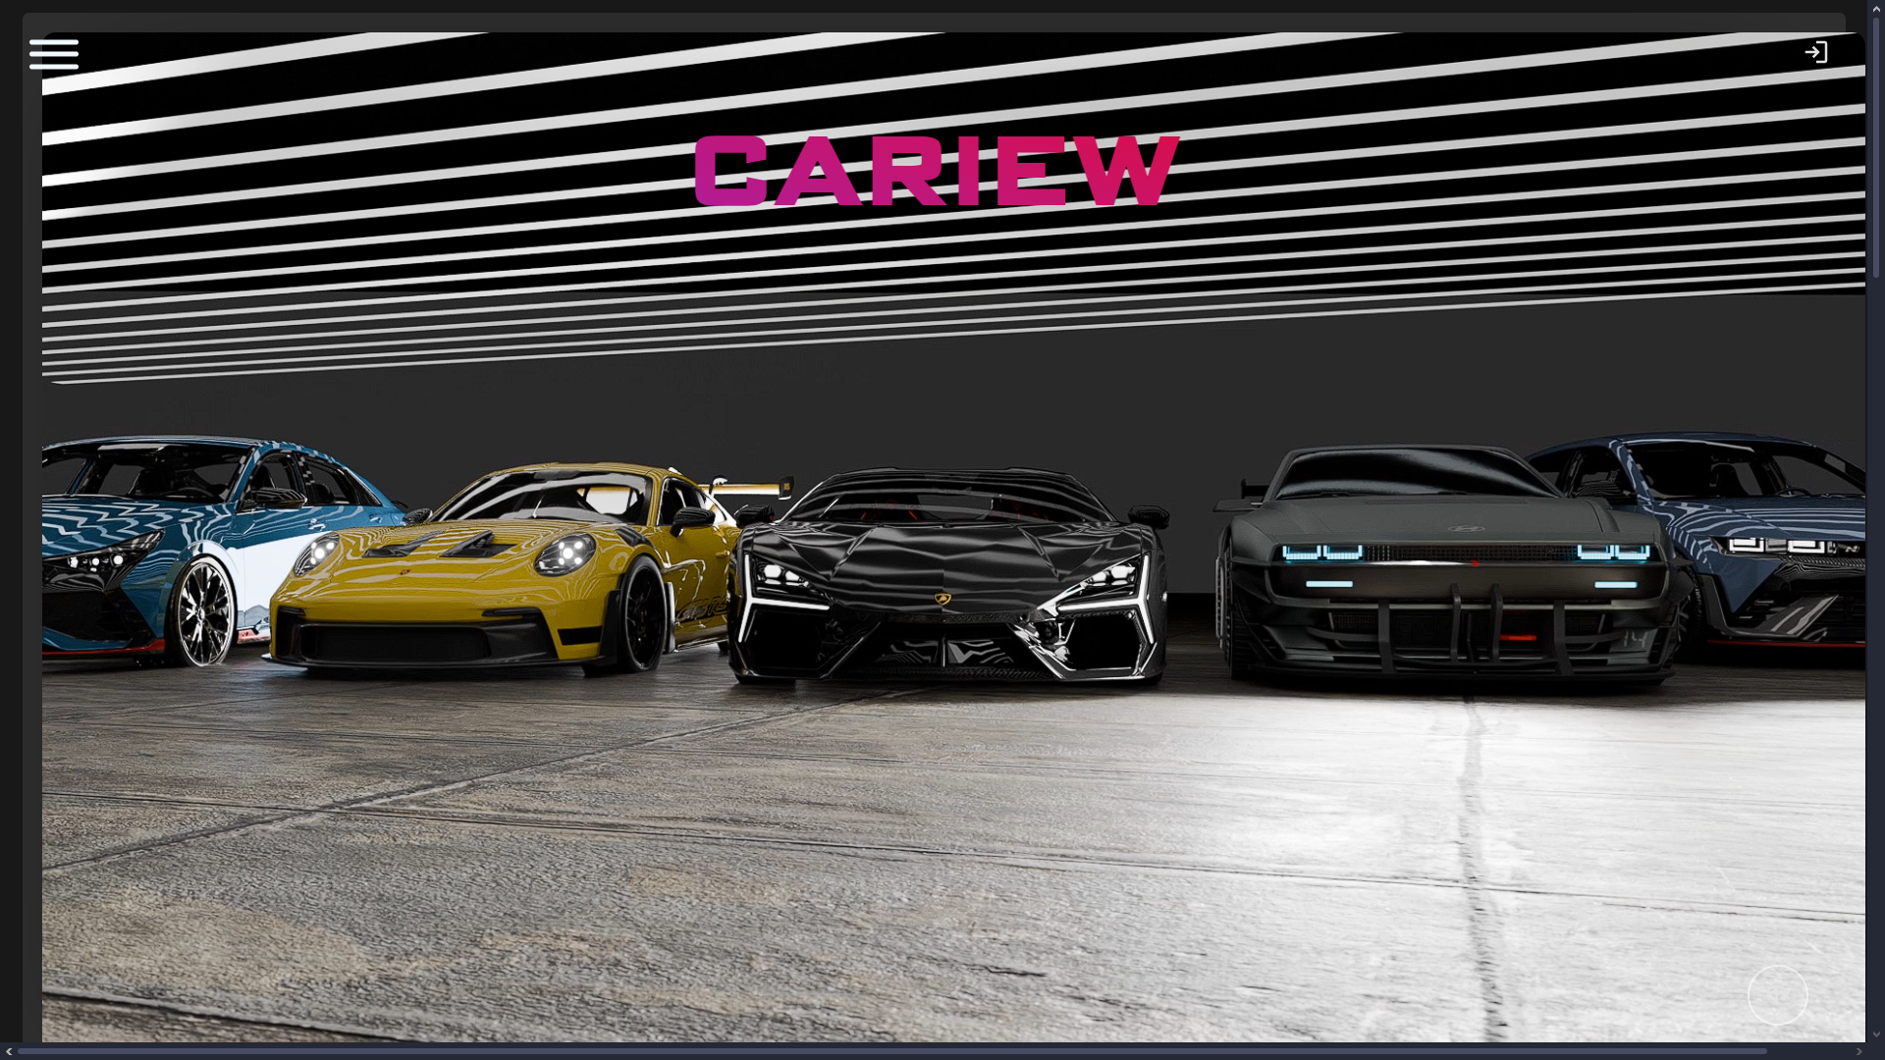

**Intro page**(*Hero Video*)

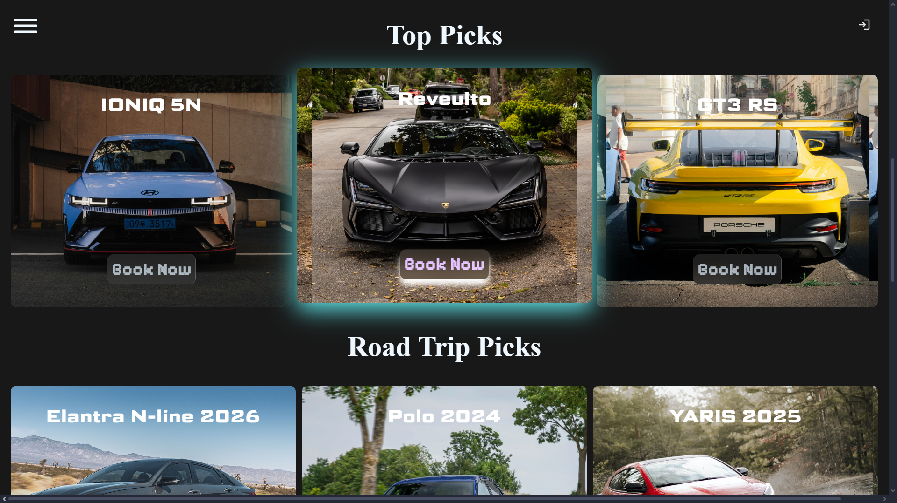  
**Car Cards**

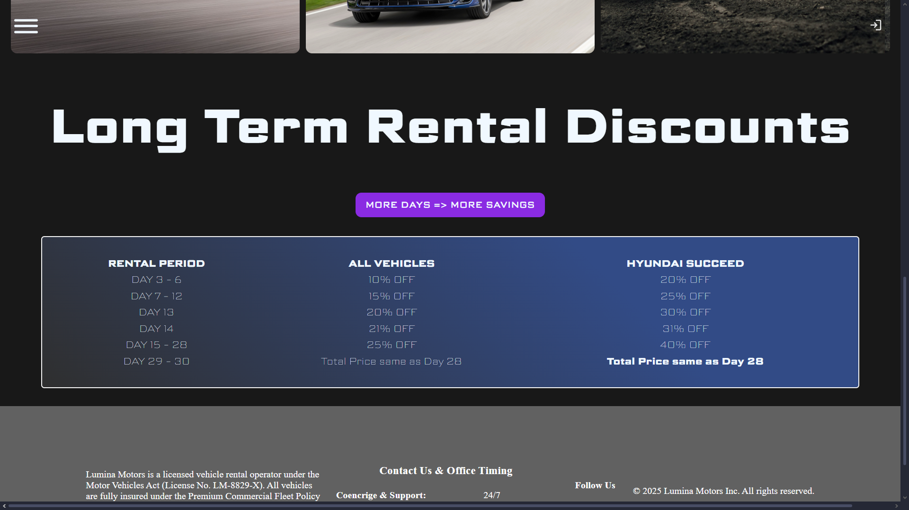

Interactive discount table(hover effect over text)

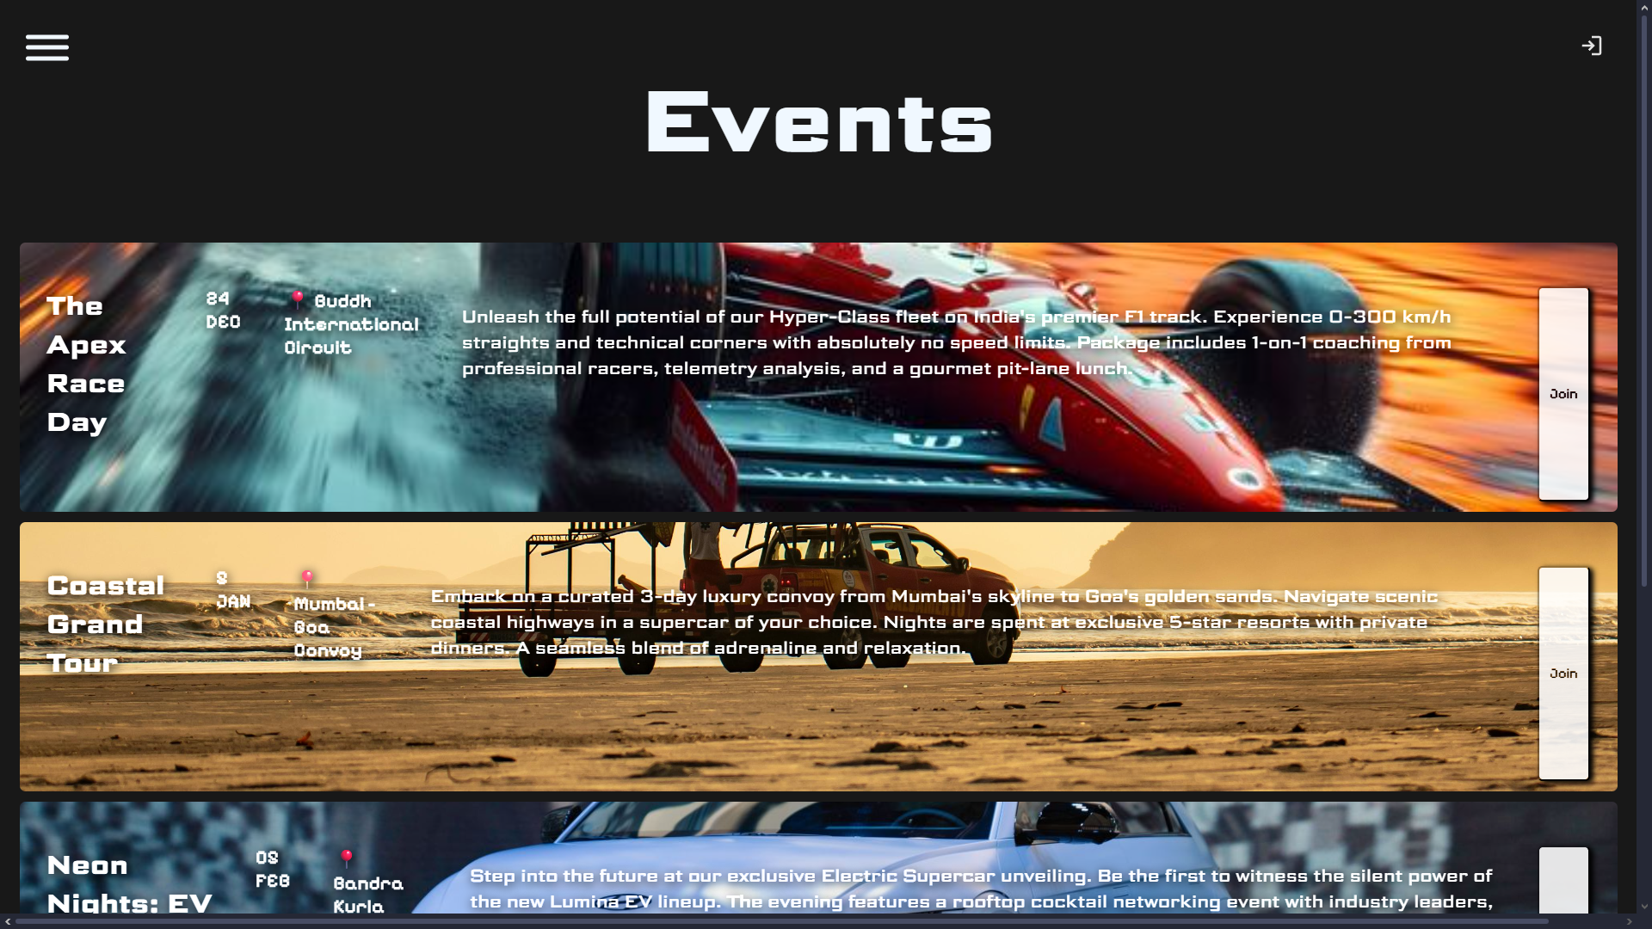

**Events Page – (**list of upcoming car events)

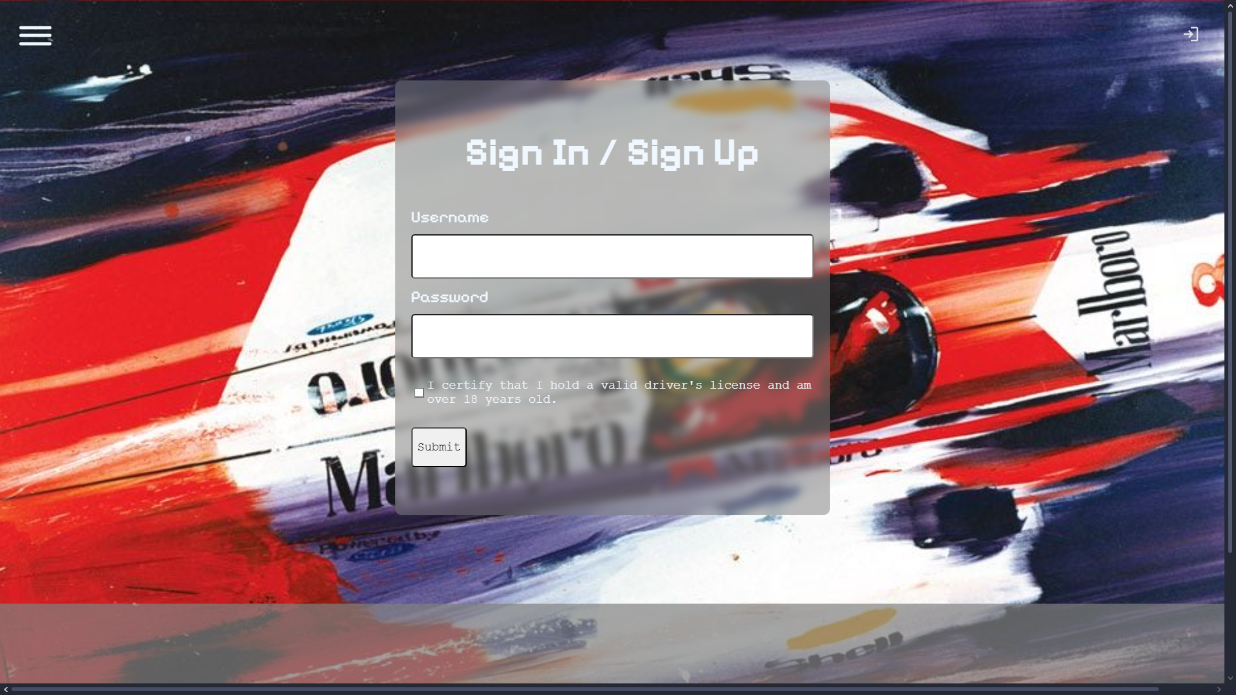

**Log-in Page** (Just the Frontend)

**7. Conclusion**

The Progress on this project has been a great lesson to me. I’ve gained knowledge about specificity about specificity in CSS and basics of JavaScript. Inclusion of 3d rendering with blender has refreshing to me. Mostly importantly I need a better roadmap as certain points, it became hard to see what is left to complete. I also learnt importance of modularity of code, that has helped along way building it

**8. Future Enhancements (Optional)**

Build a proper backend with a database(like SQL,PHP) to add cars available for rent and remove them when their not. This would also allow to filter cars on different properties. We also a need a 404 Error page when user tries to access a page that’s not present . I would also like to include components from popular Libraries like react native to build UI. We can also include Payment Gateways, User Dashboard, Smart Suggestions for Cars

**9. References**

<https://www.nrt-rentacar.jp/en/>

<https://sketchfab.com/categories/cars-vehicles>

<https://www.blender.org>

Gemini for dummy text